Arexis
Genetic Database Tool

Design Specification

Version 1

Prevas AB

Contents

1 GENERAL 2
2 System overview 2
2.1 Clients 2
2.2 Webserver 2
2.3 Database server 2
3 Software Architecture 2
3.1 Overview 2
3.2 Client software 2
3.2.1 GUI-User mode 2
3.2.2 GUI-Administration mode 2
3.3 Webserver 2
3.3.1 Servlet layer 2
3.3.2 Database access layer 2
3.3.3 Utilities 2
3.4 Database server 2
3.4.1 PL/SQL layer 2
3.4.2 SQL layer 2
4 Security aspects 2
4.1 Certificates 2
4.2 Login procedure 2
5 Configuration 2
6 ERROR HANDLING 2
7 DEVELOPMENT TOOLS 2
8 Version handling 2
8.1 Release strategies 2
8.2 Tagging 2
8.2.1 Release tagging 2
8.2.2 Branch tagging 2
8.2.3 Developer tagging 2
8.2.4 Tagging examples 2
8.2.5 Tagging summary 2
9 REFERENCES 2
10 DoCument versions 2

GENERAL
The Arexis Genetic Database tool is a web based client-server system.
The user inteface is made up of a set of HTML pages and users can view and manipulate information retrieved from a database by navigating through the system using a web browser.


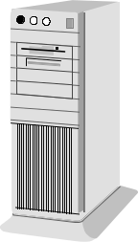
Webserver / databaseserver
Clients

The system resides on a webserver on which the HTML pages can be reached.
A database server (possibly the same machine as the webserver) is used for storage of all data used within the system. The webserver retrieves data from and writes data to the database server whenever necessary. The system has been designed for usage by a smaller amount of clients working with large amounts of data on a LAN/Intranet.
For a complete description of the systems functionality, see [1].

System overview

Clients
A web browser is needed to gain access to the system user interface that is presented as HTML pages. The system is designed to work with Internet Explorer 5 or later on Windows platforms, Netscape 4 or later on Linux platforms and Netscape 6 on MAC OS.

Webserver
The webserver used is Apache 1.3.0 on a Linux platform (redhat 6.2 recommended).
An ApacheJserv 1.3.11 module add-on is used as servlet engine, and the server is configured with openssl-0.9.4 for encrypted communication. For a more detailed description on how the system uses openssl, see reference [7]. The javapacket classes12 provided by Oracle is required on the webserver for database connectivity and the webserver also needs JDK1.2.2 and JSDK2.0 for running the java code.

Database server
The system used is Oracle 8.1.5 relational database and runs either on a Linux (redhat 6.2 recommended) or Windows (2000 recommended) platform. The database can run on a separate server or on the webserver itself.

Software Architecture

Overview
The system uses an N-layer architecture for data transfer between the user interface (the HTML-pages) and the database. The top layer runs on the client browser, the following two layers run on the webserver, whereas the two bottom layers reside within the Oracle environment itself. By only manipulating data through the PL/SQL layer in the database, a safer and more efficient data handling can be established.

HTML layer
A browser is used on the client,
Interpreting the HTML and Javascript sent from the server

Client / Browser

HTTP/HTTPS via TCP/IP

Servlet layer
Java-servlets producing the HTML pages requested by clients.

Webserver

Database access layer
Java-classes used for communication with the PL/SQL-layer within the database
Utilities
Java-classes for analyse-generating, file parsing, GQL handling etc

JDBC/ODBC

PL/SQL layer
Methods needed to manipulate data in the database tables.

Databaseserver

SQL layer
The data model. Tables, views and methods for organizing the data.

All user communication with the system is carried out through the servlet layer. Generally, when the servlet layer needs data from the database to present to the user, it is read directly from the SQL layer. When the servlet layer needs to write, change or delete data in the database, it is done through the database access layer to ensure safe transactions.

Client software
The only requirement on the client side is a supported OS and a supported browser (see 2.1 Clients). The intention has been to use very thin clients within the system, to avoid compatibility problems and to minimize client-side installation costs. The system on this level consists of a set of webpages, using HTML and JavaScript code. The code is dynamically produced by the servlets running on the webserver.

There are two different modes in which to log onto the system, user mode and administration mode. The normal user reaches one set of pages customized to present and manipulate genetic data, whereas logging on to the system as administrator gives access to another set of pages customized for user and project administration.

GUI-User mode
The user is presented a generic navigation toolbar at the top of the page. Using this, all various subsections in the system can be reached. The information in the system is devided into a set of main areas, as seen in the example below.

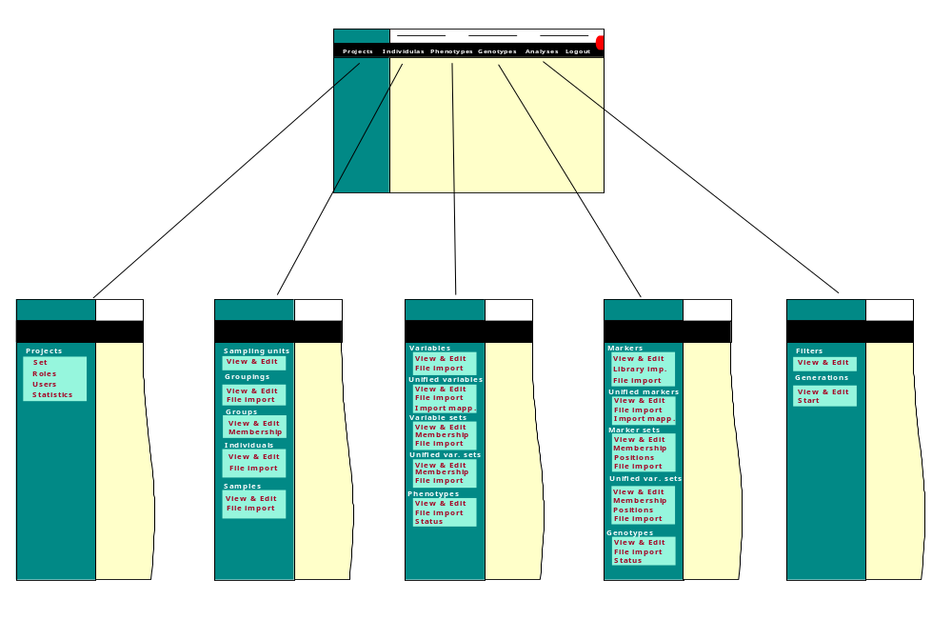

Each subsection contains a menu of choices concerning that specific subsection presented on the left side of that subsection page. Through this menu, various subsection specific pages can be reached, as seen in the example below.

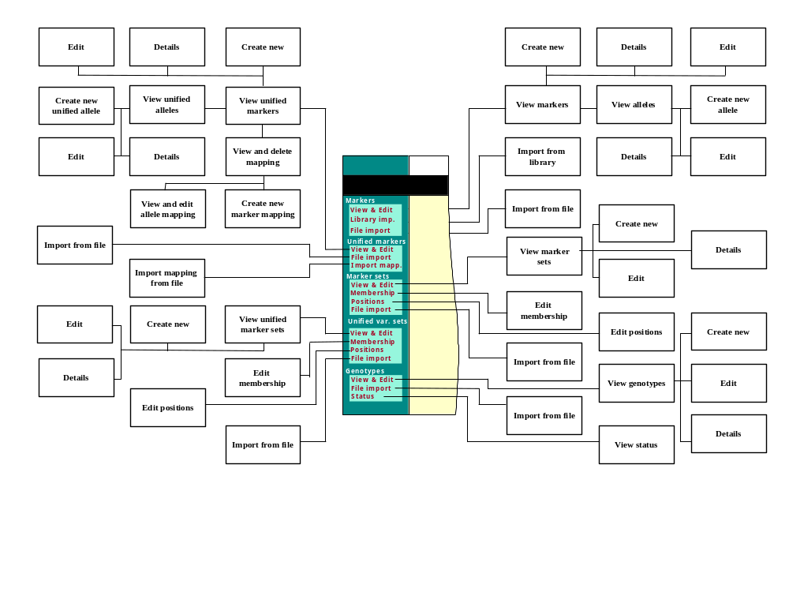
For a more detailed description of the functionality within each subsection, see reference [1].

GUI-Administration mode
When logging on as administrator of the system, a menu of choices for administrative functionality is displayed to the left of the page. By using the menu, a number of pages for viewing and editing various parts of the database can be reached, as shown in the example below.
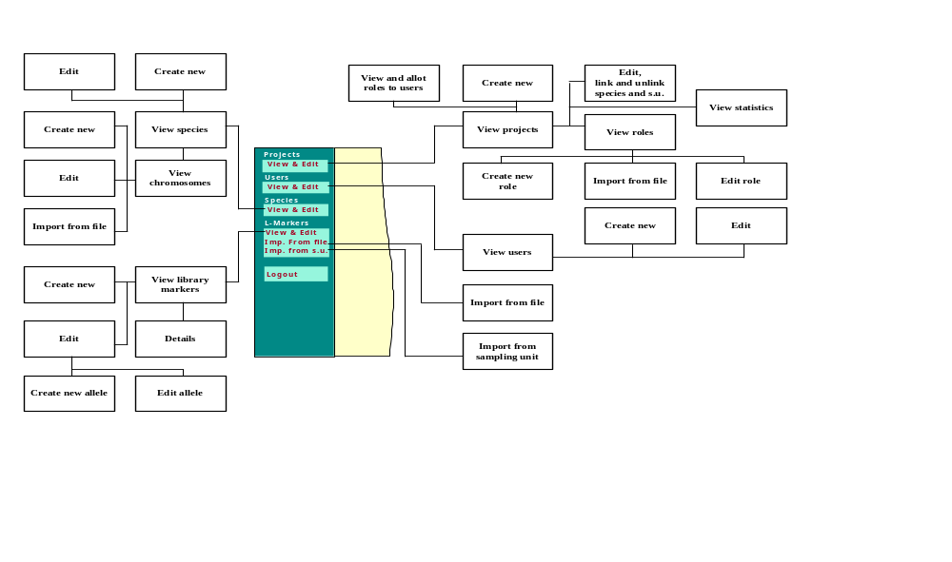

Webserver

Servlet layer
All servlets run in the java environment held by Jserv on the webserver. The servlets produce HTML pages containing data read from the database, Client requests are always passed via HTTPS requests from the HTML pages to the servlets. The Servlets will respond to these requests by sending the requested pages back to the client’s browser.

Data needed from the database for presentation is retrieved directly from various views found in the database layer. When a servlet needs to write data to the database, it is carried out through the database access layer (se below). Generally there is one servlet containing the functionality related to each specific database table. All communication with servlets requires the https protocol. For a detailed description of each servlet, see reference [2].

Database access layer
This layer is made up of a set of java classes which, via the PL/SQL-layer described below, has access to the database. These classes handle all data manipulation such as creation, deletion, copying and updating of data in the database. Generally there is one class corresponding to each type of object (each table) in the database. For a detailed description of each class and its functionality, see [3].

Utilities
A number of helpful classes for file parsing, fileuploading, GQL translating and other specific tasks are needed on the web server. See [4] for more details.

Database server

PL/SQL layer
The PL/SQL layer provides an API public to the database access layer (and to the servlet layer if required). It is made up of a number of methods written in the PL/SQL-language and can be used to manipulate data in the database. The methods have direct access to the objects/tables in the database. Working through this API is a more controlled and safe way to manipulate data in the database.

Generally, there are methods in the PL/SQL layer corresponding to each method found in the database access layer, since the database access classes makes all calls to the database through this API. This also means that like described in the section “Database access layer”, there is a set of methods in the PL/SQL layer corresponding to each table in the database. These include at least the basic functionality of creating, deleting and updating table rows for most tables. For a detailed description of the PL/SQL layer API, see [5].

SQL layer
The database layer is the implementation of the system data model itself (se reference 1, “Functional Description”). All data are organized in a number of database tables. Generally, there is one table for each type of data stored in the system and also a corresponding log table to keep a change history for that table. In many cases, there are also relational tables for storing relations between these tables. A number of Views are also available so that data can be presented in a more customized and organized way. All Views uses data from database tables for their presentation. The database views can be seen as a “read only” API towards the database tables. The Servlet layer uses these Views to read organized data from the database. For a detailed description of the SQL layer Views and tables, see [6].

Security aspects

Certificates
The system uses the HTTPS protocol for secure transactions and both server and client side certificates are required. For a detailed description on the use of certificates and other security aspects of the system, see [7].

Login procedure
The login and authentication process starts at the login.html page, which is a static HTML page on the webserver. The user provides a username and a password. These credentials are sent to the server for authentication when the user presses the login button. For a detailed description on the login procedure, see [2].

Configuration
Some features of the system are controlled by initialization parameters read by servlets at startup. The initialization parameters can be found in the dbtool.properties file under the apache configuration library. For more information on configuration and initialization parameters, see [2].

ERROR HANDLING
When possible, the error handling follows the layer structure of the system. Errors occurring in the database layer, for example exceptions thrown by Oracle when trying to create a table row, are propagated up to the user and presented in the html pages.

Exceptions thrown by Oracle are caught in the PL/SQL layer and an attempt is made to determine nature of the error. An error string with a suggestion to the cause of the problem is composed and returned to the calling class in the Database access layer.

The calling class retrieves the error string, adds some additional error information if possible and stores the new string for the servlet layer to handle.

The calling Servlet will realize that an error occurred and send an error page to the client presenting the information retrieved from the error string.

Other possible types of errors and exceptions, which cannot or should not be presented to the user are caught if possible, and a message is written to the webserver’s error log.

For more information of the error handling of the system, consult the module descriptions of each layer ([2] – [6]).

DEVELOPMENT TOOLS
All Java code is written and compiled in Oracle JDeveloper 3.1.1.2 (including jsdk1.2.2). PL/SQL procedures and SQL scripts written in the Oracle 8.1.5 environment.

Version handling
The project will use CVS for source code version control. By default, CVS prevents users from updating the same files at the same moment. The repository will be stored on one of our servers and hence be included in the normal backups.

As the project is relatively small, most development will take place in the main branch (the “trunk”). However, any developer may use a branch to isolate his changes whenever he finds it appropriate. For example, a branch might be a good solution when one developer implements large changes that will affect the other developers. In such a case it is preferred that the changes do not affect others until they are tested. A branch is an elegant way to solve this.

Release strategies
All development should be done in increments. One increment should include approximately 6-8 weeks of development. Increment releases are numbered x.1, x.2, etc. Increment releases are always parts of a major release. Such releases will be released approximately once per year and are numbered 1.0, 2.0 etc. No development is focused on the major releases. Instead, whenever the project management believes it is suitable, the project will step to a new major release. In addition to major and increment releases there are bugfix releases. Such releases include urgent fixes to minor problems. As there will be a rather short release interval, bugfixes should not include any new functionality. Instead, new functionality should only be included in the increment releases.

Tagging
The following types of tagging may occur:
- Release tagging
- Branch tagging
- Developer tagging

The following subsections describe these types more thoroughly.

Release tagging
Before any new release, no matter what kind of release, the source should be tagged with a release tag. Release tags should be named the following way: Rel_[major release version]-[increment release version]-[bugfix number]_[yyyymmdd]. In a major release the increment version should be 0. If the release is not a bugfix, that part should be left out in the tag name. Examples of valid release tags:

Rel_1-0_20010501 Rel_5-2_19990101 Rel_1-3-1_19951025

Branch tagging
There are two types of branches: developer branches (created by a developer to isolate his changes) and bugfix branches. Branching should always be done from a tag. For bugfix branches this is not a problem as they generally are branched from a release (which is tagged). For developer branches, an extra tag has to be created. This also applies to bugfix branches that are not branched from a release tag. Such tags (branch point tags) should be named bp_[userid]_[branch name]. Naturally, the opening bp is used to indicate that this is a branch point. The tag can be useful if one in the future want to retrieve the trunk as it was the moment the branch was created. The branch name part of the tag should be the same as the name of the branch. The name should reflect the purpose of the branch. Valid branch point tags might be:

bp_frob_fileparser bp_roca_autoupdate bp_anny_export

When a valid branch point tag exists, the branch itself can be created. Bugfix branches should be named b_bugfix_[user]_[branch name] while developer branches should be named b_[user]_[branch name]. The b in the beginning of the tag name is used to indicate that this is a branch tag. The branch name should reflect the purpose of the branch. For example:

b_frob_fileparser b_bugfix_roca_HTMLlayout

During work on a branch, a developer may add developer tags as often he finds suitable. A description on how to use developer tags can be found in section 8.2.3 Developer tagging.

While developer tagging is optional, tagging before merging back to the trunk is absolutely necessary. If such tags are omitted, it will be almost impossible to continue working on a branch and merge it to the trunk a second time after it once has been merged. This might be necessary if for example one has to continue working on a bugfix branch after it once has been merged. Hence, always tag the branch with a merge point tag before merging back to the trunk! Such tags should be named mp_[user]_[branch name]_[number]. The opening mp in the tag name indicates that this tag is a merge point. The number in the tag should be increased for each tag, eg:

mp_frob_fileparser_1 mp_frob_fileparser_2 mp_roca_HTMLlayout_1

Finally, after merging back to trunk, always tag the source again with a merge tag (remember to commit first!). Such tags should have the same name and the same number as the merge point tag that was used in the merge. The only difference is that a merge tag should start with an m to indicate that this is a merge. For example:

m_frob_fileparser_1 m_frob_fileparser_2 m_roca_HTMLlayout_1

Developer tagging
Developer tags are tags set by a developer whenever he finds it suitable. Although not necessary, such tags may be set at any time during development. Developer tags can be used on the trunk as well as on branches. There are two preferred ways of naming developer tags. In main, tags should be named [user]_[purpose]_[number] and on branches they should be named [user]_[branch name]_[number]. In both cases, number should be increased for each tag. However, as developer tags is primary for the developer himself, deviations from these naming conventions are acceptable. Examples of valid developer tags are:

frob_restructuring_1 anny_before_delete_1 roca_HTMLlayout_1

Tagging examples
The rules on how to use tags are here exemplified. The example starts off with the first release of the software. Then there is an untagged version followed by a version tagged with a developer tag by user frob (frob_restructuring_1).

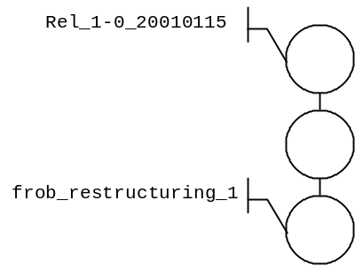

A bug in the release is discovered. The task of fixing the bug is assigned to user roca. The bugfix branch can be branched from the release tag, so roca does not need to create any branch point tag. He starts with creating the bugfix branch (b_bugfix_roca_stupidBug), fixes the bug and checks in a version that he tags with a developer tag (roca_stupidBug_1). Then he does some additional changes and checks in yet another version.

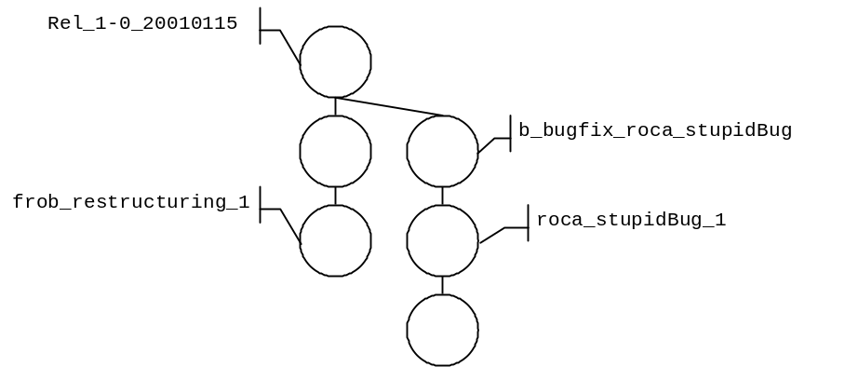

Now it is time to deliver the bugfix so roca tags the source with a release tag (Rel_1-0-1_20010129). Roca also takes a look at the source code in the trunk and discovers that the bug is not fixed there. This means that he has to merge the bugfix branch back to the trunk in order to fix it there too. Before merging, roca tags the branch with a merge point tag (mp_roca_stupidBug_1). Actually, this step is not really necessary as the merge point tag will be on the same version as the release tag. However, adding the merge point tag won’t hurt and will make the tagging more homogenous. Roca then does the merge and checks in the source. Finally, he tags the trunk with a merge tag (m_roca_stupidBug_1).
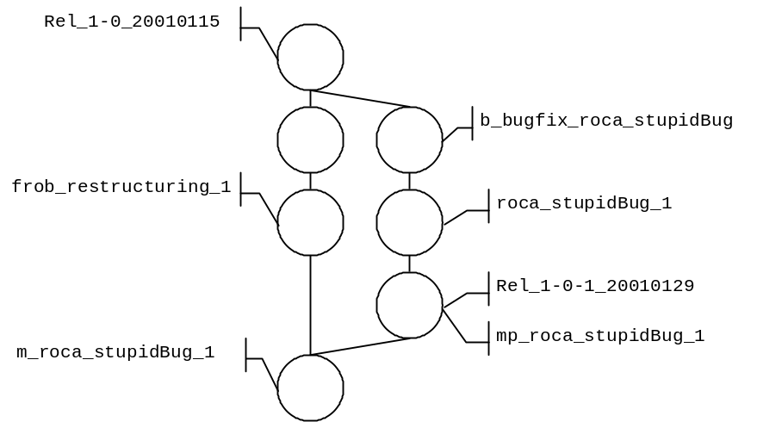
Now someone checks in an untagged version of the file in the trunk before user anny realizes he has to do some major changes. He believes he better do these changes in a separate branch to isolate the changes. As this is not a bugfix branch, he will have no tag to branch from. Hence he has to create a branch point tag. He creates the tag bp_anny_majorFix and a branch from it (b_anny_majorFix).
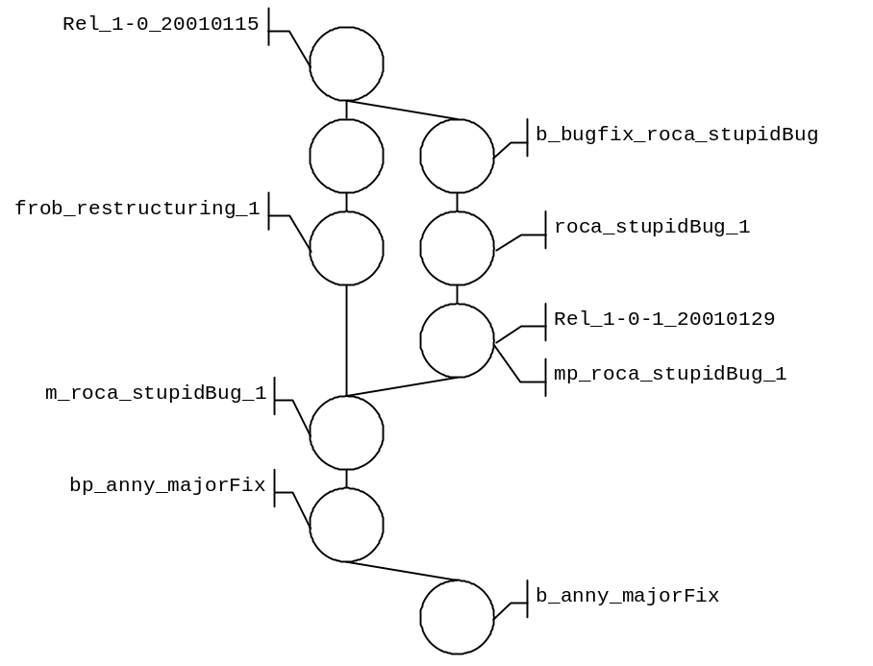
Anny does the major fixes in the branch. He checks in several versions but does not tag any of them. Meanwhile user frob does some changes in the trunk that he tags with a developer tag (frob_minorChange_1). When anny is done on the branch, he tags the branch with a merge point tag (mp_anny_majorFix_1) and merges back to main. He checks in the source and tags main to indicate that this is the point where the changes in the majorFix branch were merged (m_anny_majorFix_1). Finally, a new release tag is attached to the trunk (Rel_1-1_200010209).

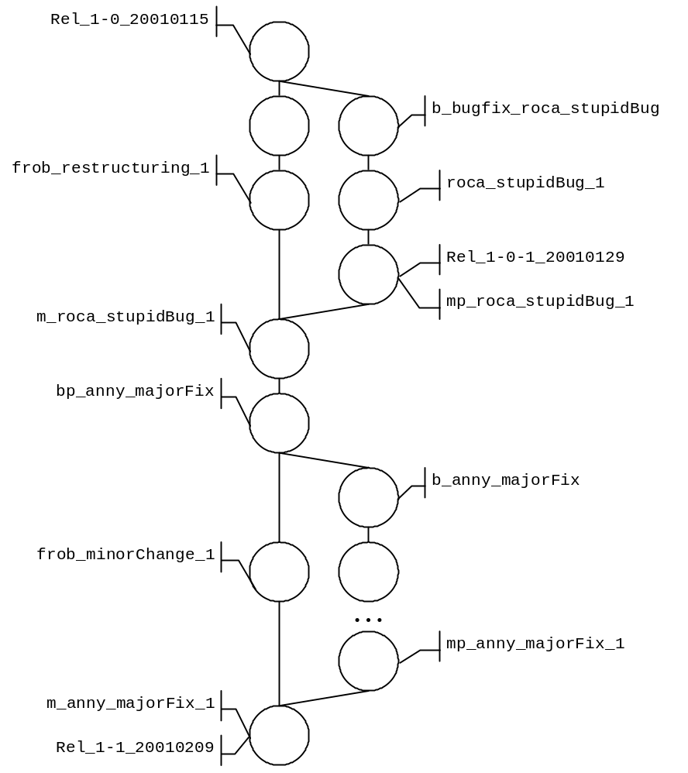

Tagging summary
Below are a summary of acceptable tags, their structure and the purpose with them.
Tag type | Structure | Example | Purpose
Release tag | Rel_[major version]-[increment version]-[bugfix number]_[yyyymmdd] | Rel_1-0_20010420  Rel_5-2-1_20010101 | Indicates a release.
Branch point tag | bp_[user]_[branch name] | bp_frob_change1 | Indicates that a branch was branched from that point.
Branch tag | b_[user]_[branch name] OR  b_bugfix_[user]_[branch name] | b_frob_change1  b_bugfix_roca_fix1 | To indicate a branch.
Merge point tag | mp_[user]_[branch name]_[number] | mp_frob_change1_1  mp_roca_fix1_3 | To indicate a point where the branch was merged.
Merge tag | m_[user]_[branch name]_[number] | m_frob_change1_1 | To indicate a point where a branch has been merged back.
Developer tag | [user]_[purpose]_[number] OR  [user]_[branch name]_[number] | frob_smallFix_1  roca_fix1_5 | To help the developer.

REFERENCES
- LL060a02 Arexis Genetic Database Tool – Functional Description, Prevas AB, 2002
- LL060c02 Arexis Genetic Database Tool – Servlet Layer, Prevas AB, 2002
- LL060c03 Arexis Genetic Database Tool – Database Access Layer, Prevas AB, 2002
- LL060c04 Arexis Genetic Database Tool – Utilities, Prevas AB, 2002
- LL060c05 Arexis Genetic Database Tool – PL/SQL Layer, Prevas AB, 2002
- LL060c06 Arexis Genetic Database Tool – SQL Layer, Prevas AB, 2002
- LL060b01 Arexis Genetic Database Tool – System Installation, Prevas AB, 2002
- LL060b02 Arexis Genetic Database Tool – Backup and Recovery, Prevas AB, 2002

DoCument versions
Version | Date | Comment | Responsible
V1p1 | 2001-03-08 | First draft | ROCA
V1p2 | 2001-03-27 | Modified draft | ROCA
V1 | 2002-05-06 | First version | FROB

